Citizen Grievance & Sentiment Analysis System
SUBMITTED BY UVESH SHAIKH

Week 3 Report: Sentiment Analysis and Priority Scoring

1. Introduction

In Week 3, the focus of the project was to analyze the emotional tone of citizen complaints and assign priority levels based on their severity. Sentiment analysis was performed to classify complaints into different categories, enabling better understanding and prioritization of public issues.

2. Sentiment Analysis Approach

Since the dataset does not contain predefined sentiment labels, a lexicon-based approach was used for sentiment analysis. The TextBlob library was applied to determine the polarity of each complaint based on its textual content.

The complaints were classified into three categories:
- Positive
- Neutral
- Negative

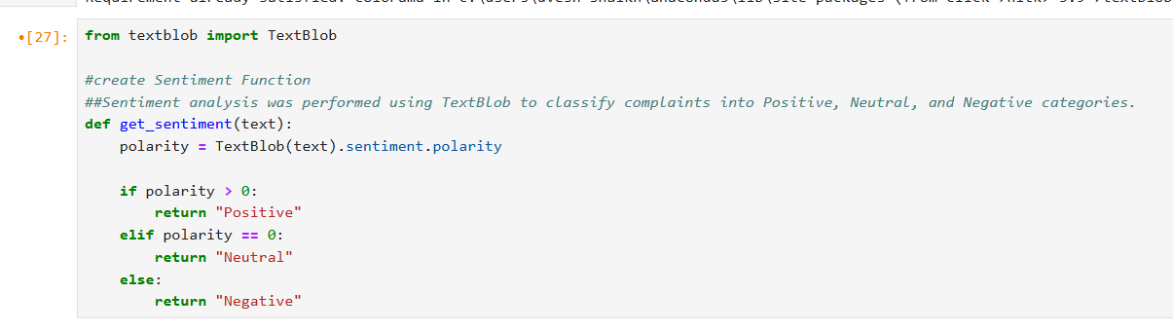

3. Applying Sentiment Analysis

The sentiment classification function was applied to the cleaned text data to generate a new column representing the sentiment of each complaint.

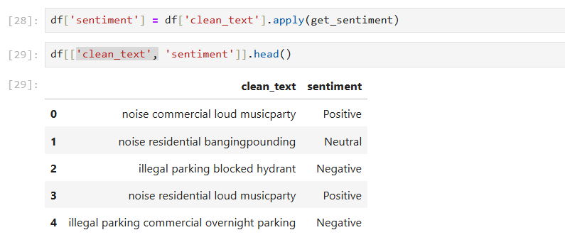

4. Sentiment Distribution Visualization

A bar chart was created to visualize the distribution of sentiments across all complaints. This helps in understanding the overall emotional trend of citizen feedback.

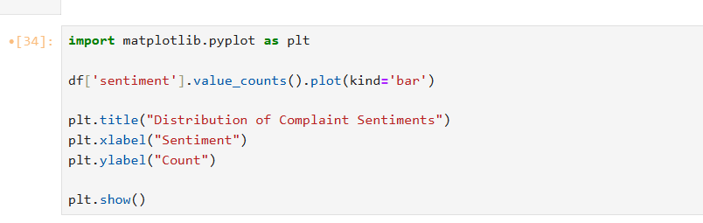

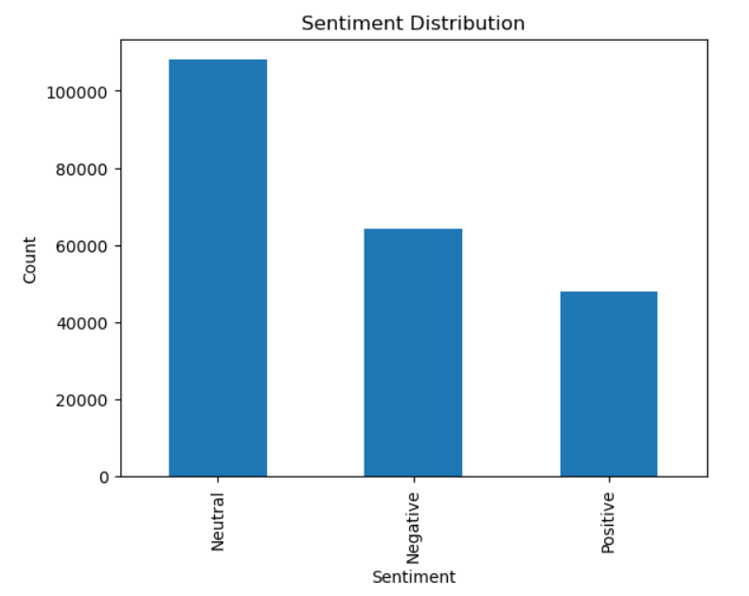

5. Priority Scoring System

To improve complaint handling, a priority level was assigned based on sentiment. Complaints with negative sentiment were considered more urgent compared to neutral and positive ones.
Priority Mapping:
- Negative → High Priority
- Neutral → Medium Priority
- Positive → Low Priority

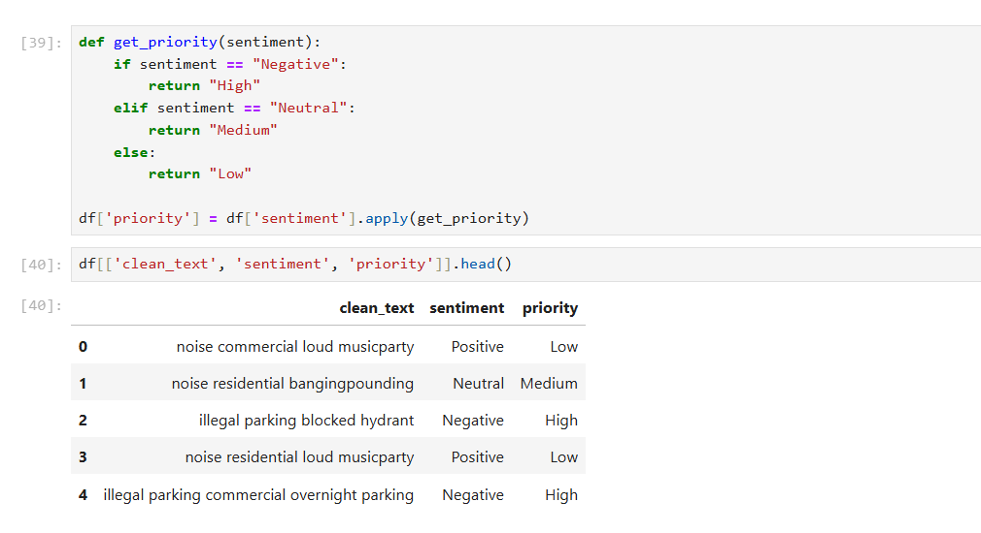

7. Key Insights

- Most complaints fall under Negative and Critical categories, indicating dissatisfaction among citizens
- Sentiment analysis helps in identifying urgent issues automatically
- Priority scoring enables efficient handling of complaints based on severity
- The system reduces manual effort in sorting and prioritizing complaints

8. Conclusion

In Week 3, sentiment analysis was successfully implemented to classify complaints based on their emotional tone. A priority scoring system was also developed to rank complaints according to urgency. This approach enhances the efficiency of grievance management systems by enabling faster identification and resolution of critical issues.
Future improvements may include the use of advanced transformer-based models such as BERT for more accurate sentiment classification.

